DAY-10 727721euit002-Abinaya.S

TASK-1:

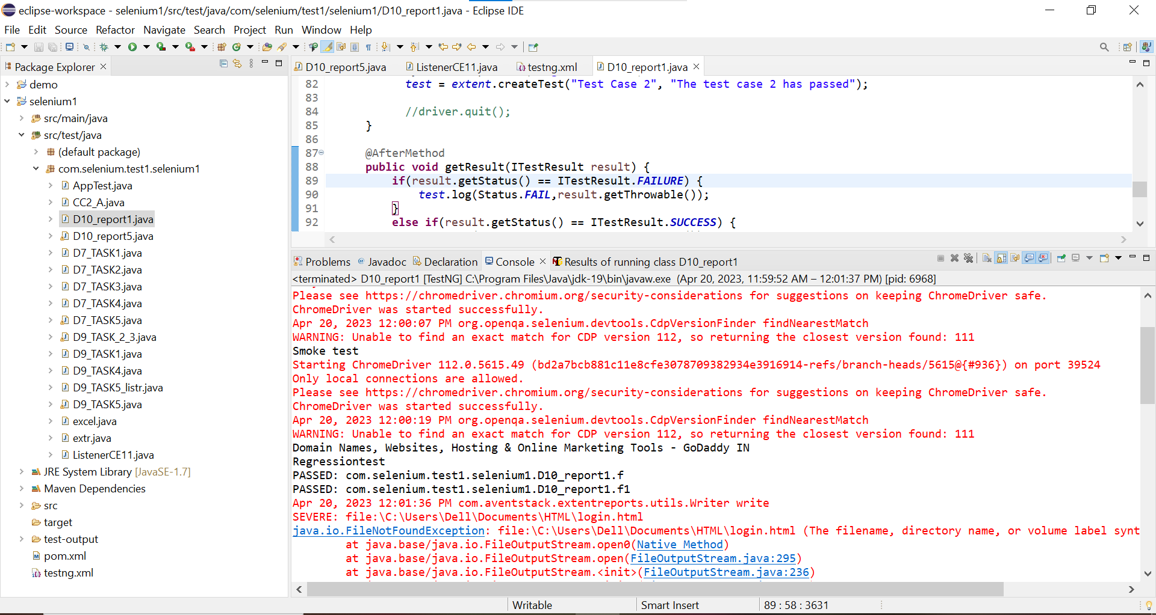

package com.selenium.test1.selenium1;

import org.openqa.selenium.By;

import org.openqa.selenium.WebDriver;

import org.openqa.selenium.chrome.ChromeDriver;

import org.openqa.selenium.chrome.ChromeOptions;

import org.testng.Assert;

import org.testng.ITestResult;

import org.testng.annotations.AfterMethod;

import org.testng.annotations.AfterTest;

import org.testng.annotations.BeforeClass;

import org.testng.annotations.Test;

import com.aventstack.extentreports.ExtentReports;

import com.aventstack.extentreports.ExtentTest;

import com.aventstack.extentreports.Status;

import com.aventstack.extentreports.reporter.ExtentHtmlReporter;

import com.aventstack.extentreports.reporter.configuration.ChartLocation;

import com.aventstack.extentreports.reporter.configuration.Theme;

import io.github.bonigarcia.wdm.WebDriverManager;

public class D10_report1 {

static ExtentTest test;

static ExtentReports extent;

ExtentHtmlReporter htmlReporter;

@BeforeClass

public void startReport() {

//ExtentSparkReporter htmlReporter = new ExtentSparkReporter("extentReport.html");

//htmlReporter = new ExtentHtmlReporter(System.getProperty("user.dir")+"/test-output/extentReport.html");

htmlReporter = new ExtentHtmlReporter("file:///C:/Users/Dell/Documents/HTML/login.html");

extent = new ExtentReports();

extent.attachReporter(htmlReporter);

//configuration items to change the look and feel

//add content, manage tests etc

htmlReporter.config().setChartVisibilityOnOpen(true);

htmlReporter.config().setDocumentTitle("Simple Automation Report");

htmlReporter.config().setReportName("Test Report");

htmlReporter.config().setTestViewChartLocation(ChartLocation.TOP);

htmlReporter.config().setTheme(Theme.STANDARD);

// htmlReporter.config().setTimeStampFormat("EEEE, MMMM dd, yyyy, hh:mm a '('zzz')'");

}

@Test

public void f() {

WebDriverManager.chromedriver().setup();

WebDriver driver;

ChromeOptions co = new ChromeOptions();

co.addArguments("--remote-allow-origins=*");

driver=new ChromeDriver(co);

driver.get("https://www.godaddy.com/en-in");

driver.manage().window().maximize();

String actualTitle="Domain Names, Websites, Hosting & Online Marketing Tools - GoDaddy IN";

String extractedTitle=driver.getTitle();

Assert.assertEquals(actualTitle, extractedTitle);

String actualURL="https://www.godaddy.com/en-in";

String extractedURL=driver.getCurrentUrl();

Assert.assertEquals(actualURL, extractedURL);

System.out.println("Smoke test");

driver.quit();

test = extent.createTest("Test Case 1", "The test case 1 has passed");

}

@Test

public void f1() throws Exception {

WebDriverManager.chromedriver().setup();

WebDriver driver;

ChromeOptions co = new ChromeOptions();

co.addArguments("--remote-allow-origins=*");

driver=new ChromeDriver(co);

driver.get("https://www.godaddy.com/en-in");

driver.manage().window().maximize();

driver.navigate().refresh();

//driver.manage().timeouts().implicitlyWait(5, TimeUnit.SECONDS);

//driver.manage().timeouts().implicitlyWait(10,TimeUnit.SECONDS);

Thread.sleep(3000);

driver.findElement(By.xpath("//*[@id=\"id-e6aaf13d-272e-44df-903a-e07e539d57c7\"]/span[1]")).click();

//driver.findElement(By.linkText("Domain Name Search")).click();

System.out.println(driver.getTitle());

System.out.println("Regressiontest");

test = extent.createTest("Test Case 2", "The test case 2 has passed");

//driver.quit();

}

@AfterMethod

public void getResult(ITestResult result) {

if(result.getStatus() == ITestResult.FAILURE) {

test.log(Status.FAIL,result.getThrowable());

}

else if(result.getStatus() == ITestResult.SUCCESS) {

test.log(Status.PASS, result.getTestName());

}

else {

test.log(Status.SKIP, result.getTestName());

}

}

@AfterTest

public void tearDown() {

//to write or update test information to reporter

extent.flush();

}}

TASK-4

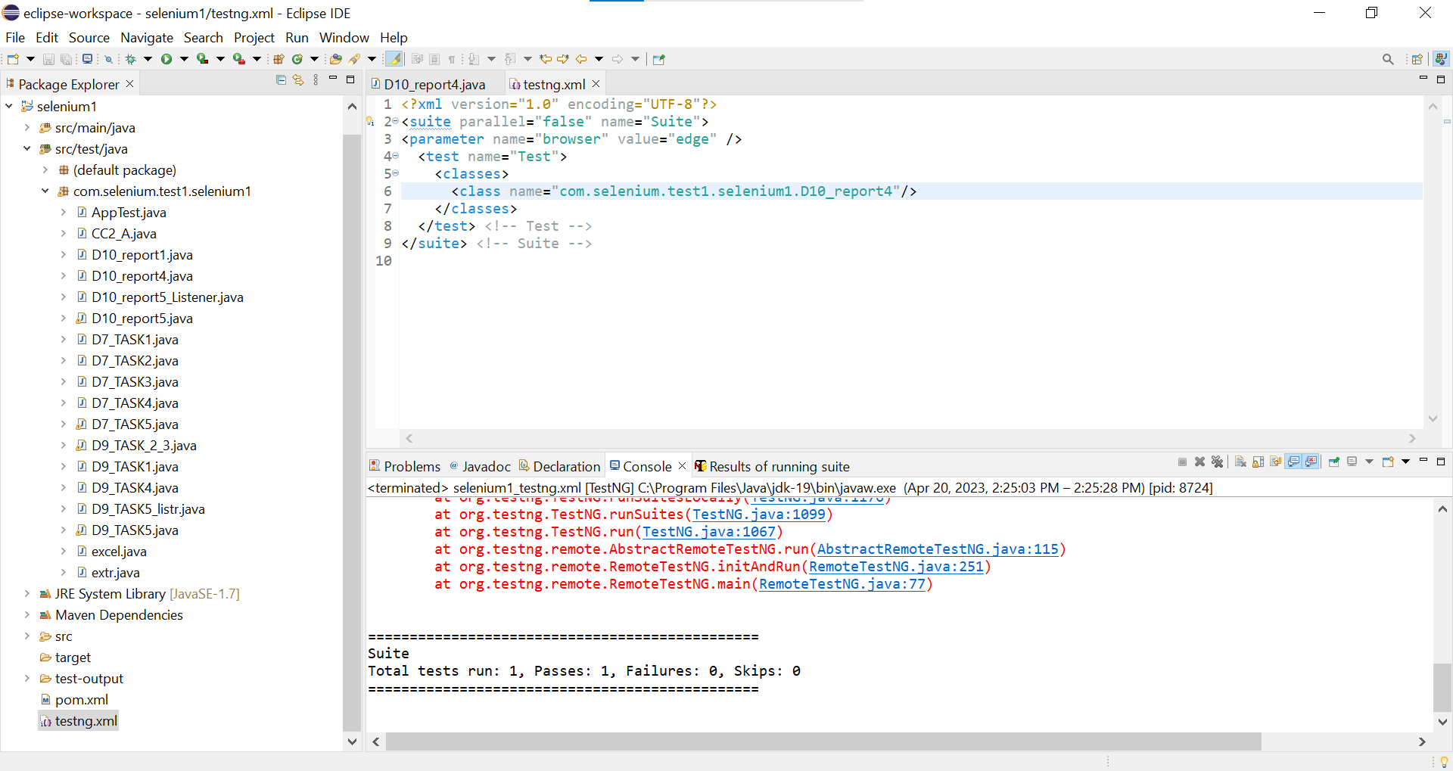

**package** com.selenium.test1.selenium1;

**import** java.awt.AWTException;

**import** java.io.IOException;

**import** org.openqa.selenium.By;

**import** org.openqa.selenium.WebDriver;

**import** org.openqa.selenium.WebElement;

**import** org.openqa.selenium.chrome.ChromeDriver;

**import** org.openqa.selenium.chrome.ChromeOptions;

**import** org.openqa.selenium.edge.EdgeDriver;

**import** org.testng.ITestResult;

**import** org.testng.annotations.AfterMethod;

**import** org.testng.annotations.AfterSuite;

**import** org.testng.annotations.BeforeMethod;

**import** org.testng.annotations.Parameters;

**import** org.testng.annotations.Test;

**import** com.aventstack.extentreports.ExtentReports;

**import** com.aventstack.extentreports.ExtentTest;

**import** com.aventstack.extentreports.Status;

**import** com.aventstack.extentreports.reporter.ExtentHtmlReporter;

**import** com.aventstack.extentreports.reporter.configuration.ChartLocation;

**import** com.aventstack.extentreports.reporter.configuration.Theme;

**import** io.github.bonigarcia.wdm.WebDriverManager;

**public** **class** D10_report4 {

WebDriver driver;

**static** ExtentTest *test*;

**static** ExtentReports *extent*;

ExtentHtmlReporter htmlReporter;

@Test

**public** **void** f() **throws** Exception {

Thread.*sleep*(3000);

WebElement uname=driver.findElement(By.*name*("username"));

WebElement pwd=driver.findElement(By.*name*("password"));

WebElement submit=driver.findElement(By.*xpath*("//*[@class='oxd-button oxd-button--medium oxd-button--main orangehrm-login-button']"));

uname.sendKeys("Admin");

pwd.sendKeys("admin123");

submit.click();

*test* = *extent*.createTest("Test Case 1", "The test case 1 has passed");

}

@Parameters("browser")

@BeforeMethod()

**public** **void** beforeMethod(String browser1) {

htmlReporter = **new** ExtentHtmlReporter("file:///C:/Users/Dell/Documents/HTML/login.html");

*extent* = **new** ExtentReports();

*extent*.attachReporter(htmlReporter);

//configuration items to change the look and feel

//add content, manage tests etc

htmlReporter.config().setChartVisibilityOnOpen(**true**);

htmlReporter.config().setDocumentTitle("Simple Automation Report");

htmlReporter.config().setReportName("Test Report");

htmlReporter.config().setTestViewChartLocation(ChartLocation.***TOP***);

htmlReporter.config().setTheme(Theme.***STANDARD***);

**if**(browser1.equals("chrome"))

{

WebDriverManager.*chromedriver*().setup();

ChromeOptions co = **new** ChromeOptions();

co.addArguments("--remote-allow-origins=*");

driver=**new** ChromeDriver(co);

driver.manage().window().maximize();

String url="https://opensource-demo.orangehrmlive.com/web/index.php/auth/login";

driver.get(url);

driver.manage().window().maximize();

}

**else** **if**(browser1.equals("edge"))

{

WebDriverManager.*edgedriver*().setup();

//FirefoxOptions co = new FirefoxOptions();

//co.addArguments("--remote-allow-origins=*");

driver=**new** EdgeDriver();

driver.manage().window().maximize();

String url="https://opensource-demo.orangehrmlive.com/web/index.php/auth/login";

driver.get(url);

driver.manage().window().maximize();

}

}

@AfterMethod

**public** **void** getResult(ITestResult result) **throws** AWTException, IOException {

**if**(result.getStatus() == ITestResult.***FAILURE***) {

*test*.log(Status.***FAIL***, result.getTestName());

}

**else** **if**(result.getStatus() == ITestResult.***SUCCESS***) {

*test*.log(Status.***PASS***, result.getTestName());

}

**else** {

*test*.log(Status.***SKIP***, result.getTestName());

}

}

@AfterSuite

**public** **void** afterMethod() {

*extent*.flush();

//driver.close();

}

}

testng.xml:

<?xml version="1.0" encoding="UTF-8"?>

<suite parallel="false" name="Suite">

<parameter name="browser" value="edge" />

<test name="Test">

<classes>

<class name="com.selenium.test2.test2.D10C4"/>

</classes>

</test> <!-- Test -->

</suite> <!-- Suite -->

TASK-5:

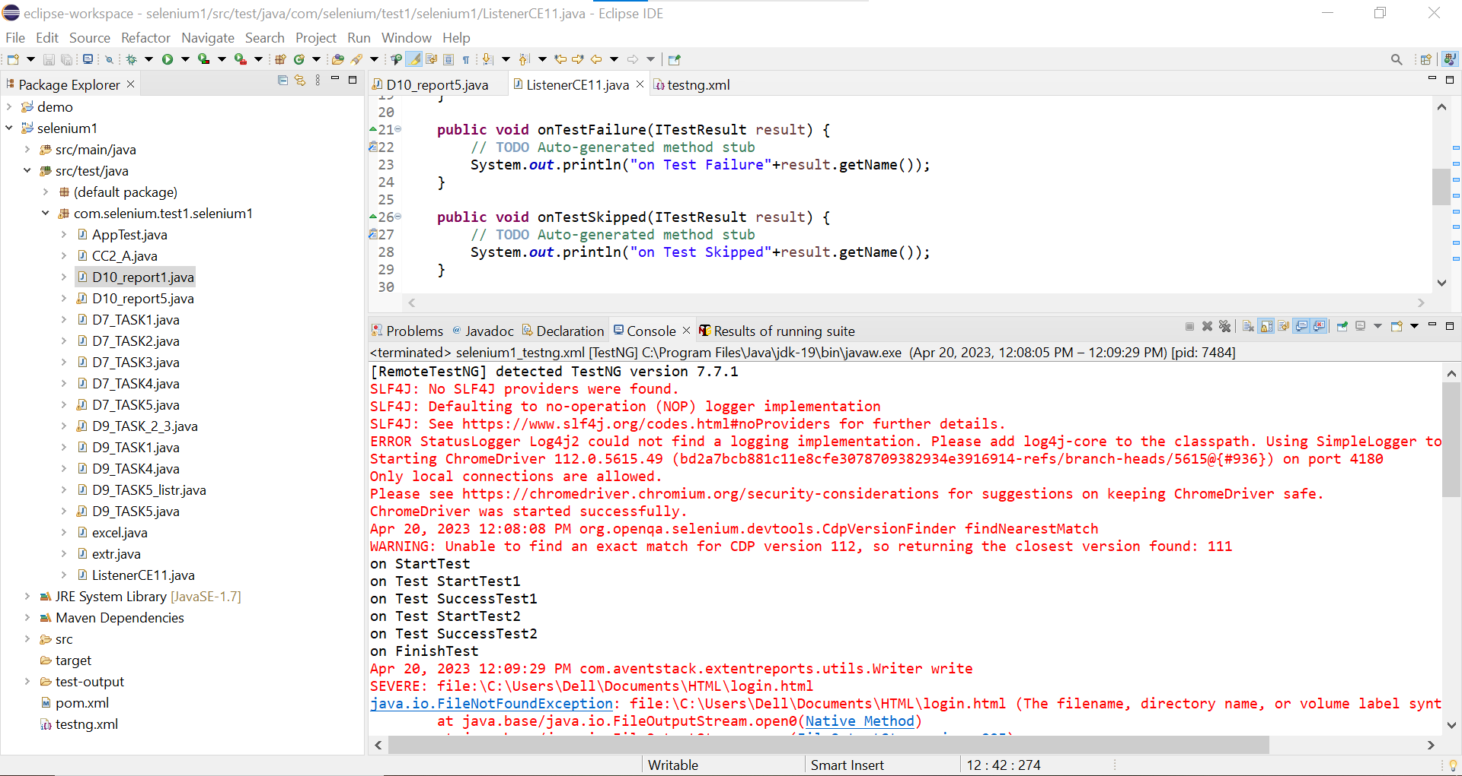

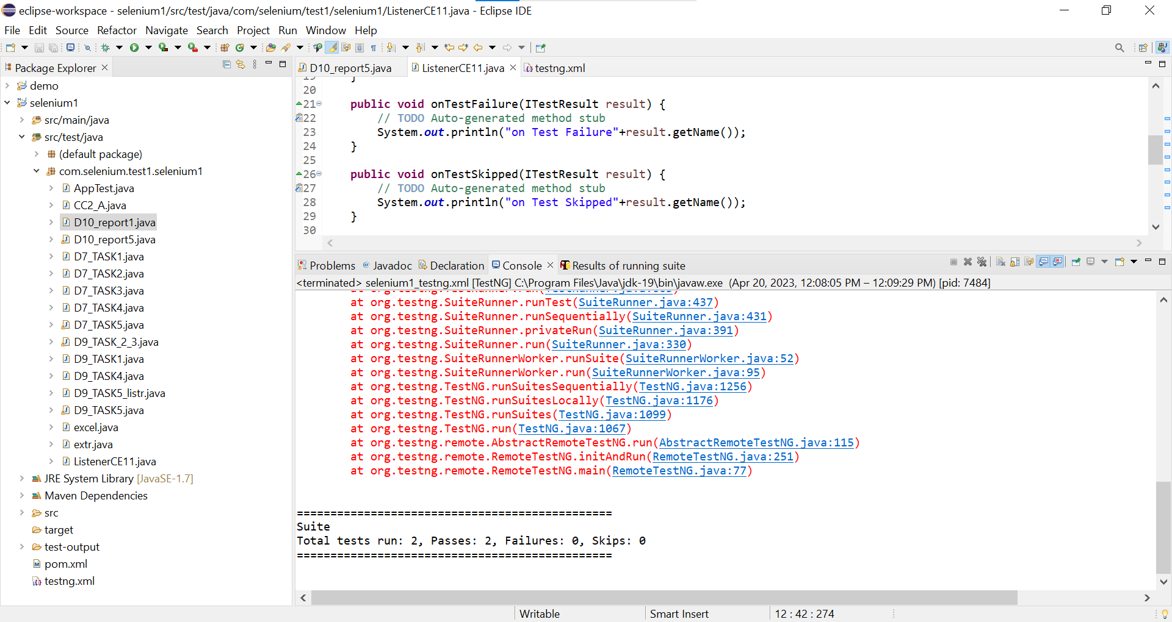

D10_report5:

**package** com.selenium.test1.selenium1;

**import** java.awt.AWTException;

**import** java.awt.Dimension;

**import** java.awt.Rectangle;

**import** java.awt.Robot;

**import** java.awt.Toolkit;

**import** java.awt.image.BufferedImage;

**import** java.io.File;

**import** java.io.IOException;

**import** javax.imageio.ImageIO;

**import** org.openqa.selenium.By;

**import** org.openqa.selenium.WebDriver;

**import** org.openqa.selenium.WebElement;

**import** org.openqa.selenium.chrome.ChromeDriver;

**import** org.openqa.selenium.chrome.ChromeOptions;

**import** org.testng.ITestResult;

**import** org.testng.annotations.AfterMethod;

**import** org.testng.annotations.AfterTest;

**import** org.testng.annotations.BeforeSuite;

**import** org.testng.annotations.Test;

**import** com.aventstack.extentreports.ExtentReports;

**import** com.aventstack.extentreports.ExtentTest;

**import** com.aventstack.extentreports.Status;

**import** com.aventstack.extentreports.reporter.ExtentHtmlReporter;

**import** com.aventstack.extentreports.reporter.configuration.ChartLocation;

**import** com.aventstack.extentreports.reporter.configuration.Theme;

**import** io.github.bonigarcia.wdm.WebDriverManager;

**public** **class** D10_report5 {

WebDriver driver;

**static** ExtentTest *test*;

**static** ExtentReports *extent*;

ExtentHtmlReporter htmlReporter;

String sstloc="C:\\Users\\Dell\\OneDrive\\Pictures\\Screenshots\\2022-09-19.png";

@BeforeSuite

**void** init()

{

WebDriverManager.*chromedriver*().setup();

ChromeOptions co = **new** ChromeOptions();

co.addArguments("--remote-allow-origins=*");

driver=**new** ChromeDriver(co);

htmlReporter = **new** ExtentHtmlReporter("file:///C:/Users/Dell/Documents/HTML/login.html");

*extent* = **new** ExtentReports();

*extent*.attachReporter(htmlReporter);

//configuration items to change the look and feel

//add content, manage tests etc

htmlReporter.config().setChartVisibilityOnOpen(**true**);

htmlReporter.config().setDocumentTitle("Simple Automation Report");

htmlReporter.config().setReportName("Test Report");

htmlReporter.config().setTestViewChartLocation(ChartLocation.***TOP***);

htmlReporter.config().setTheme(Theme.***STANDARD***);

}

@Test

**void** Test1() **throws** InterruptedException

{ *test* = *extent*.createTest("Test Case 1", "The test case 1 has passed");

String url="https://opensource-demo.orangehrmlive.com/web/index.php/auth/login";

driver.get(url);

Thread.*sleep*(3000);

WebElement uname=driver.findElement(By.*name*("username"));

WebElement pwd=driver.findElement(By.*name*("password"));

WebElement submit=driver.findElement(By.*xpath*("//*[@class='oxd-button oxd-button--medium oxd-button--main orangehrm-login-button']"));

uname.sendKeys("Suvitha");

pwd.sendKeys("12345");

submit.click();

String url1="https://opensource-demo.orangehrmlive.com/web/index.php/dashboard/index";

}

@Test()

**void** Test2() **throws** InterruptedException

{ //WebElement logout=driver.findElement(By.linkText("Logout"));

//logout.click();

driver.close();

}

@AfterMethod

**public** **void** getResult(ITestResult result) **throws** AWTException, IOException {

**if**(result.getStatus() == ITestResult.***FAILURE***) {

screencapture(sstloc);

*test*.log(Status.***FAIL***,result.getThrowable());

*test*.addScreenCaptureFromPath(sstloc);

}

**else** **if**(result.getStatus() == ITestResult.***SUCCESS***) {

*test*.log(Status.***PASS***, result.getTestName());

}

**else** {

*test*.log(Status.***SKIP***, result.getTestName());

}

}

@AfterTest

**public** **void** tearDown() {

//to write or update test information to reporter

*extent*.flush();

}

**void** screencapture(String sstloc1) **throws** AWTException, IOException

{

Robot robot=**new** Robot();

Dimension scr_size=Toolkit.*getDefaultToolkit*().getScreenSize();

Rectangle rect=**new** Rectangle(scr_size);

BufferedImage scrshot=robot.createScreenCapture(rect);

File dest=**new** File(sstloc1);

ImageIO.*write*(scrshot,"png",dest);

}

}

ListenerCE11.java:

**package** com.selenium.test1.selenium1;

**import** org.testng.ITestContext;

**import** org.testng.ITestListener;

**import** org.testng.ITestResult;

**public** **class** ListenerCE11 **implements** ITestListener {

**public** **void** onTestStart(ITestResult result) {

// **TODO** Auto-generated method stub

System.***out***.println("on Test Start"+result.getName());

}

**public** **void** onTestSuccess(ITestResult result) {

// **TODO** Auto-generated method stub

System.***out***.println("on Test Success"+result.getName());

}

**public** **void** onTestFailure(ITestResult result) {

// **TODO** Auto-generated method stub

System.***out***.println("on Test Failure"+result.getName());

}

**public** **void** onTestSkipped(ITestResult result) {

// **TODO** Auto-generated method stub

System.***out***.println("on Test Skipped"+result.getName());

}

**public** **void** onTestFailedButWithinSuccessPercentage(ITestResult result) {

// **TODO** Auto-generated method stub

System.***out***.println("on Test FailedButWithinSuccessPercentage"+result.getName());

}

**public** **void** onTestFailedWithTimeout(ITestResult result) {

// **TODO** Auto-generated method stub

System.***out***.println("on Test FailedWithTimeout"+result.getName());

}

**public** **void** onStart(ITestContext context) {

// **TODO** Auto-generated method stub

System.***out***.println("on Start"+context.getName());

}

**public** **void** onFinish(ITestContext context) {

// **TODO** Auto-generated method stub

System.***out***.println("on Finish"+context.getName());

}

}

testng.xml:

<?xml version="1.0" encoding="UTF-8"?>

<suite parallel="false" name="Suite">

<test name="Test">

<listeners>

<listener class-name="com.selenium.test1.selenium1.ListenerCE11">

</listener>

</listeners>

<classes>

<class name="com.selenium.test1.selenium1.D10_report5"/>

</classes>

</test> <!-- Test -->

</suite> <!-- Suite -->